EpiData Analysis Quick Guide v1.0
Basic mode of working:  Workflow follows this simple figure.  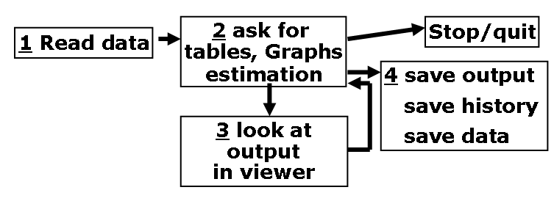  A Start the EpiData Analysis programme and compare your screen with the figure to the right. You have to press different function keys (or the window menu) to get all parts shown.  B The work-process toolbar (read..browse..graph etc) is good for beginners and has dialogs instead of commands. When you are in a dialog, for example “tables” found in “Analysis” try the different aspects and press ok. Notice that the command is then executed and added to the history,  C To repeat a command or see it again, show the history window (F7). If you click one the command is copied to the command prompt ready for editing or executed if you did a double click)..  D. The statusbar at the bottom gives information like number of observations, possible select filters, name of logfile and active folder/directory. To change folder: click or CD  E Press F1 to see precise syntax for all commands and functions. To go directly to a command in the help file: Search (ctrl+F) or write in the command prompt and press F1.  F Document data and create pgm files for reproducible work  G When output gets SLOW press F12 | 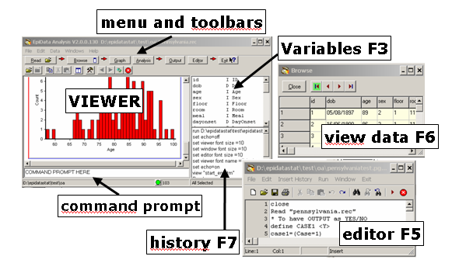
Document data with file, variable and value labels
datafile: labeldata “File v1.4 Project: Pain trial”
variable: label sex “Sex of respondent”
categories: labelvalue sex /1=”female” /2=”male”/9=”Unknown”
missing: missingvalue sex /9 // one to three values

save your datafiles: savedata “my new file” [/replace]
labels and missing are saved in “my new file.chk”

pgm file content: Insert history (all commands you executed) to the editor (F5), remove lines not desired and save as a “clean” command file (pgm), before you exit the programme.
- Continue commands on several lines by ending with: \
- Add comments in the text with a beginning: * or a later //

Then you can redo your analysis at any time, by running the pgm file. Additionaly you can send the pgm and data to someone and ask for help.

